Interdisciplinary Research and Development into
Bioscience and Biotechnology

The 13th Joint Annual Conference of CSCST-UK & SCI-CS

14 October 2006, The University of Manchester, UK



Local Information for Attendees

Organized by:
Chinese Society of Chemical Science and Technology in the UK
Society of Chemical Industry-Chinese UK Section
Biological Physics Group, The University of Manchester

Conference Venue: Lecture Theatre C9, Renold Building (Building No. 8 on the map below), Sackville Street Campus (North Campus), University of Manchester
Registration: 9:00-9:30am at the Entrance of Renold Building

How to get to The University of Manchester?
Coach Station

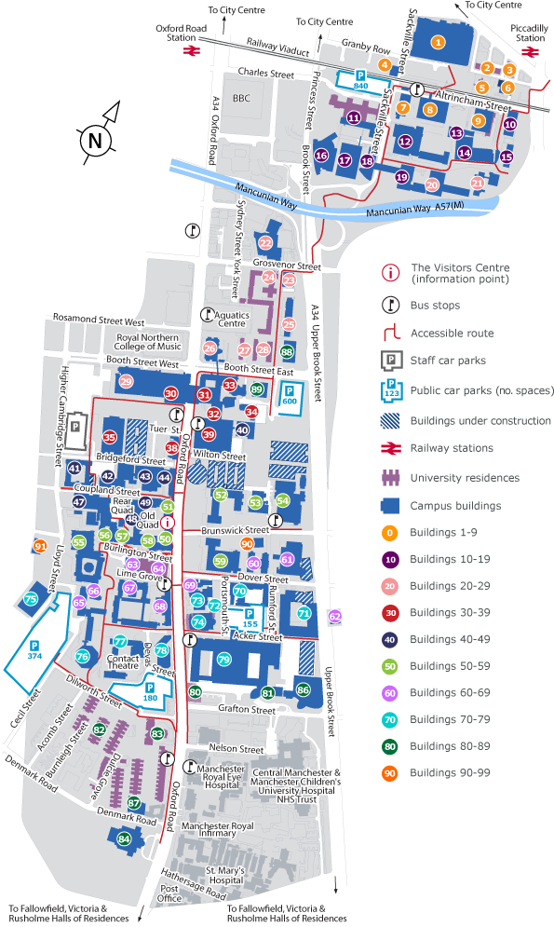
Renold Building
Sackville Street Building
Coach Station
Train Station

Arrival:

By Car

For Sackville Street Campus (following signs for The University of Manchester):

M6/M56 (Northbound)
- Exit the M6 at J19 taking the third exit at the roundabout onto Chester Road A566
- Continue straight ahead onto A50
- At the major roundabout bear right onto the M56
- Follow the M56 until it turns into the A5103 signposted for the city centre
- Take the A5103 into the centre of Manchester until you reach a major roundabout with an overpass
- Take the third exit at the roundabout onto the Mancunian Way
- Shortly bear left onto Cambridge Street
- Take the second exit at the next roundabout
- Continue straight ahead onto the Mancunian Way A57(M) 0.2 miles
- Bear left again onto A57 and continue straight ahead onto Sackville Street
- Take the second left onto Charles Street where you will find a multi-storey car park.

M62 (Westbound)
- Take the M62 east to Manchester
- Exit motorway at J20 following the A627 (M) to Oldham
- Continue straight ahead onto Broadway A663
- Bear right onto Oldham Road A62
- Continue straight ahead onto Portland Street A5103
- Turn left onto Princess Street
- Turn left onto Charles Street where you will find a multi-storey car park.

M62 (Eastbound)
- Take the M62 west to Manchester
- Exit at J12 onto the M602 Eccles bypass
- Continue straight ahead onto the A57
- Bear left onto the Mancunian Way A57(M)
- Bear left again onto the A57 and continue straight ahead onto Sackville Street
- Turn left onto Charles Street where you will find a multi-storey car park.

M6 (Southbound)
- Take the M6 South
- As you approach the outskirts of Manchester continue straight ahead onto the M61
- Shortly after, continue straight ahead onto the M60
- Continue straight ahead onto the M62 and bear right onto the M602 Eccles Bypass
- Continue straight ahead onto the A57
- Bear left onto the Mancunian Way A57(M)
- Bear left onto A57 and continue straight ahead onto Sackville Street.
- Take the second left onto Charles Street where you will find a multi-storey car park.
By Train

Piccadilly station to Sackville Street
The Sackville Street area of the campus is within 5 minutes' walk of Piccadilly Station. Leave the station via the Fairfield Street entrance (where the taxi rank is), cross London Road, and down Fairfield Street which is straight ahead of you. Continue down Fairfield Street and the Sackville Street building (No. 1 on the map) is on your left, while Renold building is on the other side of the railway bridge (Altrincham Street).

Victoria station to Sackville Street
Victoria station is about a mile from the Sackville Street area of the campus. The easiest way is to take a Metrolink tram to Piccadilly station, and follow the route described above.

Oxford Road station to Sackville Street
To get to the Sackville Street area of the campus, go down the station approach and cross Oxford Road. Then turn directly right onto Whitworth Street, and the campus is about a 5 minute walk.

By bus and coach

Directions to Sackville Street campus
Turn right out of Chorlton Street Coach Station onto Chorlton Street and walk to the junction with Whitworth Street. Cross Whitworth Street and the Sackville Street part of the campus is straight ahead.

By air
Manchester Airport located about 10 miles (16km) south of the city centre, about 30 minutes from the university.
The airport has a number of transport links to the city:
- Train - The airport's two terminals are linked directly to the city centre by a fast (30min), frequent 24 hour train link to both Piccadilly and Oxford Road stations. (recommended)
- Taxi - A taxi from the airport to the University will cost approximately £15.
- Bus - Local buses (No. 43) also run to the Oxford Road and Sackville Street areas of the campus. (it will takes 1.5hr)

Accommodation
If you need any over night accommodation, please contact Mr. XiuBo ZHAO no later than 1st October. Any fees incurred may be covered by attendees themselves.

For more local information, please contact
Mr. XiuBo ZHAO | Mr. Tao TAO
Biological Physics Group, School of Physics & Astronomy, University of Manchester, Sackville Street, M60 1QD  Tel: 0044-161-2005977  Mobile: 07906544885  Email: X.Zhao@postgrad.manchester.ac.uk | Biological Physics Group, School of Physics & Astronomy, University of Manchester, Sackville Street, M60 1QD  Tel: 0044-161-2003959  Mobile: 07725855139  Email: Tao.tao@postgrad.manchester.ac.uk
Detailed and updated information can also be found by consulting the website, http://www.cscst.org.

