 | OU Music Society Auditions  The University Orchestras
Faculty of Music
Oxford
OX1 1DB
13th October 2002
Dear Instrumentalist,
Thank you for auditioning for the University Orchestras. Unfortunately we are unable to offer you a place this term. Standards are always high with many excellent players competing for few places.
Please do continue playing and take the opportunity to join other groups such as your college orchestra. There will be another opportunity to audition if you wish – you should contact one of the managers of the University Orchestras directly to arrange this (details are below).
Yours faithfully,

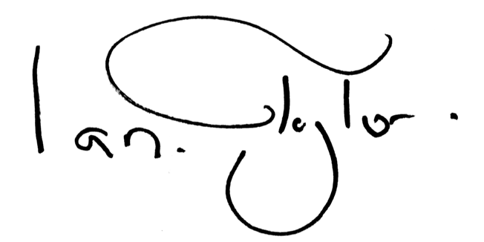

Ian Taylor
OUMS President

Contacts
Sarah Barker Manager of OUO

St John’s, sarah.barker@sjc.ox.ac.uk
Hananh Evans Manager of Philharmonia
Hertford, hannah.evans@hertford.ox.ac.uk
??? President of Chamber Orchestra

???, ???@???.ox.ac.uk
Sally Franklin Manager of Wind Orchestra

St John’s, sally.franklin@sjc.ox.ac.uk
Ellen Wiles Manager of Sinfonietta

St Anne’s, ellen.wiles@st-annes.ox.ac.uk

Andrew Ker Auditions Co-ordinator

Univ, secretary@oums.org

OU Music Society Auditions
The University Orchestras
Faculty of Music
Oxford
OX1 1DB
13th October 2002
Dear Instrumentalist,
Thank you for auditioning for the University Orchestras. Unfortunately we are unable to offer you a place this term. Standards are always high with many excellent players competing for few places.
Please do continue playing and take the opportunity to join other groups such as your college orchestra. There will be another opportunity to audition if you wish – you should contact one of the managers of the University Orchestras directly to arrange this (details are below).
Yours faithfully,

Ian Taylor
OUMS President

Contacts
Sarah Barker Manager of OUO

St John’s, sarah.barker@sjc.ox.ac.uk
Hananh Evans Manager of Philharmonia
Hertford, hannah.evans@hertford.ox.ac.uk
??? President of Chamber Orchestra

???, ???@???.ox.ac.uk
Sally Franklin Manager of Wind Orchestra

St John’s, sally.franklin@sjc.ox.ac.uk
Ellen Wiles Manager of Sinfonietta

St Anne’s, ellen.wiles@st-annes.ox.ac.uk

Andrew Ker Auditions Co-ordinator

Univ, secretary@oums.org

